
Anatomy & Physiology Part One Exam
Please read these instructions before you begin to answer the questions that follow.
You are welcome to work your answers on this paper examination for your convenience. You will submit your final answers through an uploaded file through our app. When you are satisfied that your answers are correct, use the app to download an instruction file for the corresponding lesson. This will open the lesson, so you are able to add your work for grading. Complete this file upload for grading. Only the answers on the submitted file will be considered for grading.

You have reached the end of Part 1 and are ready for your Part 1 Examination. After you complete it, log in and submit through the app. Good luck!

Instructions:
Follow the instructions for each question. Show your work in the space provided and write the answer on the line. You will need to show your work on the file submitted to your teacher for grading.
Multiple Choice (worth 2 points each): Enter your selected answer into the blank space provided.

__C___1. Which of the following is not a unit in the metric system?
  - meter
  - liter
  - Celsius
  - second

__C___2. Which of the following is made of organized groups of molecules that perform a special function?
  - atoms
  - organs
  - tissues
  - cells

_D____3. Which of the following is an example of positive feedback?
  - shivering
  - sweating
  - pH increase
  - blood clotting

__D___4. A tissue is said to be ________ when a force is removed and the object returns to its normal shape.
  - plastic
  - torqued
  - efferent
  - elastic

__A___5. A player gets hit by a lacrosse ball. What is the predominant type of force generated by the ball on the player?
  - compressive stress
  - tensional stress
  - shear stress
  - transform stress

__C___6. The tail of a phospholipid is ______________.
  - hydrophilic
  - made of linked amino acids
  - hydrophobic
  - “water loving”

__D___7. Each of the following is a component of RNA EXCEPT
  - ribose
  - thymine
  - adenine
  - sugar-phosphate

__A___8. ATP is similar to DNA because each one contains _____________.
  - an adenine base.
  - a sugar phosphate complex.
  - a double helix shape.
  - both a and b.

Use the image below to answer questions 9-10.

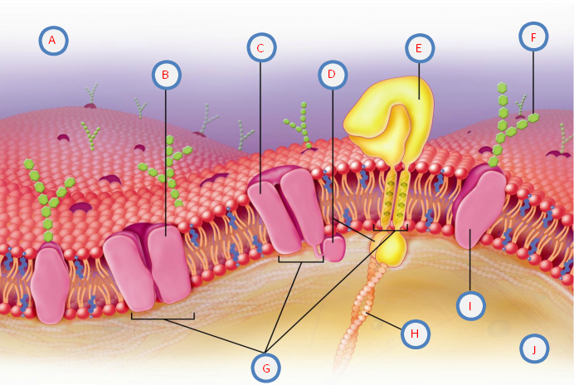

__C___9. Which of the structures labeled above allows particles to passively pass through the plasma membrane?
  - C
  - F
  - E
  - I

__C___10. The structure labeled F is responsible for communicating with the immune system. The ______________________ helps identify cells as self or non-self.
  - channel protein
  - protein pump
  - carbohydrates
  - glycoprotein

__B___11. Which connective tissue provides support for the body?
  - cartilage
  - bone
  - blood
  - adipose

__A___12. What is the function of synovial fluid?
  - provides support to a joint
  - gives cushion and reduce friction
  - resists stretching
  - offers elasticity

__C___13. The ___________ glands are found in the _________ and start functioning at puberty.
  - sudoriferous, dermis
  - merkel cell, stratum basale
  - apocrine, armpit
  - sebaceous, skin

__A___14. True or False: Psoriasis is a highly contagious disease characterized by scaly skin patches that itch, burn, crack, and sometimes bleed.
  - True
  - False

_A____15. True or False: Keratin is responsible for human skin color.
  - True
  - False

__C___16. An osteon is composed of which of the following?
  - perforating canals
  - lacunae
  - Haversian canal
  - both B and C

__D___17. What is responsible for bone lengthening in adolescents?
  - epiphyseal plates
  - ossification
  - bone marrow
  - epiphyses

Use the image below to answer questions 18-20.
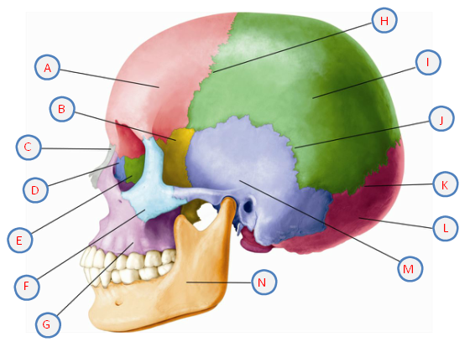

_B____18. Which structure labeled above is also known as the cheekbones?
  - E
  - F
  - G
  - H

__C___19. The structure labeled N above is the ____________ and the only movable facial bone.
  - maxillary bone
  - palatine bone
  - mandible
  - nasal bone

_B____20. Which of the following cranial bones are paired?
  - parietal
  - frontal
  - occipital
  - ethmoid

__C___21. Which structures are part of the appendicular skeleton?
  - the head and trunk
  - the spinal column
  - the arms and legs
  - none of the above

__B___22. Another term for freely moveable joints is______________.
  - synarthroses
  - amphiarthroses
  - synovial joints
  - symphyses

__B___23. What autoimmune disease results in the body attacking healthy joint tissues?
  - diabetes type i
  - rheumatoid arthritis
  - thyroiditis
  - hepatitis

_B____24. Which nervous system controls smooth muscle movement?
  - central
  - autonomic
  - somatic
  - muscular

__B___25. What chemical diffuses across the synaptic cleft when a nerve impulse reaches the axon terminal?
  - tetanus
  - neuroglia
  - acetylcholine
  - epinephrine

__C___26. Tendonitis is to tendon as ___________________________.
  - conjunctivitis is to cornea
  - rhinitis is to mucous membrane
  - tinnitus is to auditory canal
  - external otitis is to tongue

__B___27. The oblique muscles can be found ________________________.
  - on the anterior trunk
  - posterior to the rectus abdominis
  - on the lower limbs
  - around the elbow

__A___28. Which of the following is NOT true regarding action potentials in nerve impulses?
  - the inside of the membrane as an overall negative charge
  - potassium ions are found inside the cell
  - negative sodium ions are outside the cell
  - the cell membrane is polarized

__B___29. True or False: The primary motor cortex sends messages that control muscle movement and can be found anterior to the central cortex.
  - True
  - False

__D___30. The autonomic nervous system connects to the central nervous system and controls which areas of the body?
  - heart
  - smooth muscles
  - glands
  - all of the above

_B____31. What part of the eye is considered “the white of the eye?”
  - choroid
  - sclera
  - cornea
  - iris

__D___32. What part of the eye narrows or widens the pupil in response to changes in light?
  - sclera
  - cornea
  - retina
  - iris

__B___33. True or False: Blindness can be caused by long term diabetes.
  - True
  - False

__B___34. What does the ceruminous gland secrete?
  - tears
  - earwax
  - sweat
  - mucous

__D___35. Which of the following is not an example of an exocrine secretion?
  - sweat
  - saliva
  - estrogen
  - breast milk

__B___36. In a negative feedback loop, what is the next step that follows the hypothalamus and pituitary glands directing the target gland to release hormones?
  - target gland sends signals to the hypothalamus and pituitary glands
  - they hypothalamus inhibits the construction of hormones
  - the loop starts back again
  - the target gland releases the hormones and achieves the goal

__B___37. What happens when blood glucose levels drop?
  - the pancreas stimulates the production of glucagon
  - the liver converts glucose to fat
  - glucose is taken up into the cells
  - none of the above

__B___38. What regulates calcium in the body?
  - thyroid
  - parathyroid
  - thymus
  - both A and B

__B___39. The symptoms of what disorder include excessive urination, excessive thirst, and increased hunger?
  - Addison’s disease
  - diabetes mellitus
  - muscular dystrophy
  - hypothyroidism

__C___40. ______________ glands have ducts and are the counterpart of the endocrine glands.
  - Glucagon
  - Peripheral
  - Exocrine
  - Central

Essays (worth 20 points, 10 points each)

41. Describe the types of neurons, their structure and their function.

There are three essential kinds of neurons: sensory neurons, motor neurons, and interneurons. All three have exclusive functions; however, the intelligence wishes all of them to speak correctly with the relaxation of the physique and vice versa.

Sensory Neurons
Sensory neurons are neurons accountable for changing exterior stimuli from the surroundings into corresponding inside stimuli. They are activated with the aid of sensory input, and ship projections to different factors of the worried system, subsequently conveying sensory facts to the talent or spinal cord. Unlike the motor neurons of the central anxious machine (CNS), whose inputs come from different neurons, sensory neurons are activated with the aid of bodily modalities such as seen light, sound, heat, bodily contact, or with the aid of chemical alerts such as odor and taste.

Motor Neurons
Motor neurons are neurons positioned in the central apprehensive system, and they challenge their axons outdoor of the CNS without delay or not directly manage muscles. The interface between a motor neuron and muscle fiber is a specialized synapse known as the neuromuscular junction. The shape of motor neurons is multipolar, which means every cell incorporates a single axon and more than one dendrites. This is the most frequent kind of neuron.

Interneurons
Interneurons are neither sensory nor motor; rather, they act as the “middlemen” that shape connections between the different two types. Located in the CNS, they function locally, which means their axons connect solely with close by sensory or motor neurons. Interneurons can store time and consequently stop harm with the aid of sending messages to the spinal twine and again as an alternative to the brain. Like motor neurons, they are multipolar in structure.

Structures of a Neuron

In addition to having all the regular elements of a cell nucleus, organelles, neurons additionally comprise special buildings for receiving and sending the electrical alerts that make neuronal verbal exchange possible.

Dendrite
Dendrites are branch-like buildings extending away from the mobile body, and their job is to acquire messages from different neurons and permit these messages to tour to the mobile body. Although some neurons do no longer have any dendrites, different kinds of neurons have more than one dendrites. Dendrites can have small protrusions referred to as dendritic spines, which similarly make bigger floor vicinity for viable connections with different neurons.

Cell Body
Like different cells, every neuron has a cell physique or soma that incorporates a nucleus, easy and difficult endoplasmic reticulum, Golgi apparatus, mitochondria, and different cell components.

Axon
An axon, at its most basic, is a tube-like shape that contains an electrical impulse from the phone physique or from every other cell’s dendrites to the buildings at the contrary quit of the neuron—axon terminals, which can then ignore the impulse to every other neuron. The cell physique carries a specialized structure, the axon hillock, which serves as a junction between the cell physique and the axon.

Synapse
The synapse is the chemical junction between the axon terminals of one neuron and the dendrites of the next. It is a hole the place specialized chemical interactions can occur, as an alternative than a proper structure.

The feature of a Neuron
The specialized shape and employer of neurons enable them to transmit alerts in the structure of electric powered impulses from the Genius to the physique and back. Individually, neurons can ignore a sign from their dendrites to their axon terminals; however, at a greater level, neurons are equipped in lengthy chains, permitting them to omit alerts very rapidly from one to the other. One neuron’s axon will join chemically to any other neuron’s dendrite at the synapse between them. Electrically charged chemical compounds float from the first neuron’s axon to the second neuron’s dendrite, and that sign will then float from the second neuron’s dendrite, down its axon, throughout a synapse, into a third neuron’s dendrites, and so on.

This is the primary chain of neural sign transmission, which is how the talent sends indicators to the muscle mass to make them move, and how sensory organs send indicators to the brain. It is necessary that these indicators can appear quickly, and they do. Think of how speedy you drop a warm potato—before you even recognize it is hot. This is due to the fact the experience organ (in this case, the skin) sends the sign “This is hot!” to neurons with very lengthy axons that tour up the backbone to the brain. If this didn’t manifest quickly, humans would burn themselves.

42. Many of the molecules found in the body are organic.
A: Make an argument for which three biological molecules you feel are the most important for the body.

Important three biological molecules are I exhibit some examples of lipids are steroid hormones LDL cholesterol diet A and nutrition D. so there you have it the three key biological molecules that are vital to residing techniques carbohydrates proteins and lipids.

B: Water is inorganic but still essential. Could humans live without water? Why or why not?
Humans can only live to tell the tale a quick amount of time besides water due to the fact the physique desires it for nearly every process, such as regulating physique temperature thru sweating and breathing. assisting indigestion with the aid of forming saliva and breaking down food. moistening mucous membranes.

